- THE NATIONAL PEACE CORPS ASSOCIATION
- WORLDVIEW
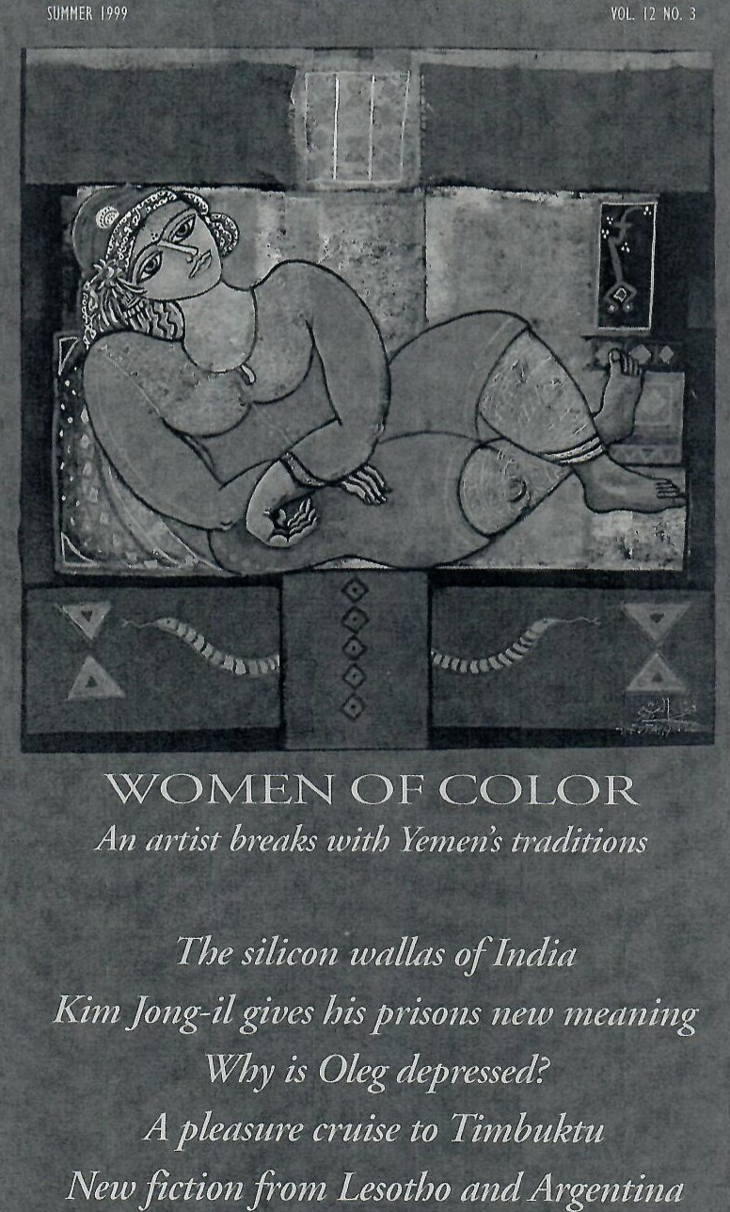

A QUARTERLY MAGAZINE ABOUT DEVELOPING WORLD PUBLISHED BY THE NATIONAL PEACE CORPS ASSOCIATION
WORLDVIEW EDITORIAL  David Arnold. editor  Charles R. Larson, books &fiction editor  Contributors:  Terry Anderson, Jim Collins, Julio Cort"zat',  Mark D rajem, David Easterbrook, Roger Essley,  Johanna Mendelson Forman, Alan Ryan,  George Gedda, James Gibbs, Sandy Greenberg,  Robert Hamilton, Perdita Huston,  Frank Roller, Joseph Kovacs, Louise Lief,  Linda Barrett Osborne, Vesna Peric•ZimonjiC, Tiian Sallah, Jeffrey Shannon, Dane Smith.  Jeffrey •rayler, Peter Zirnite  WORLDVIEW ADVERTISING  James Collins co., Washington, DC | June-August 1999  CONT  Departments  NOTE TO READERS, page 4  Making peace from the bottom up. By David Arnold.  LAFAYETTE PARK, page 8  China's ambassador tries to extend a welcome to some new Peace Corps volunteers; One of Picasso's gteat art inspirations was classical and African.  NIGER CRUISE, page 25  Poets, writers, and musicians get together on a triple-decker for a Niger River culture cruise bound for Perdita  Huston writes about the menu, the lectures, and Al Farka Touré, who joined them on the final leg of the three-day trip,  PRISON by KIM, page 41  Diplomatic correspondent George Gedda writes on Congressional testimony about criminal prison conditions in North Korea.  OLEG'S DEPRESSION, page 46 Jeffrey Tayler writes from Kiev about a longtime friend and political dissident and about the rise and fall of the human spirit.  BOOKS, page 51  Reviews: Poetry from a Malawi jail; Research on the displacement phenomenon; books about travel in Siberia and West Africa; a novel set in a Vietnamese refugee camp; an author's first novel about India's nature and its snake charmers; and controversial novels in reprint from the Galapagos, and about the North's problems with refugees from the South.  THE WIRE, page 67  News summaries from more than 90 developing countries, taken from the daily wires of the Inter Press Service. | Volume 12 Number 3  NTENTS  Arts & Letters  LETTER FROM ERITREA, page 21  In "Visit to Tserona" a former teacher sets out to find his students, and why they went to war along the borderline battlefields Of Ethiopia and Eritrea.  By Jeffrey Shannon  SILICON WALLAS, page 29  India is bidding to create an Asian home for Bill Gates and his friends, according to our correspondent in Hyderabad, Mark Drajem.  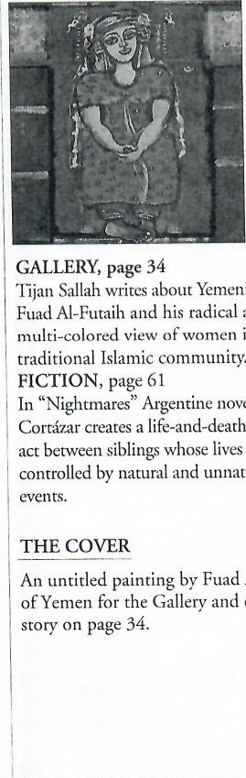  Yemeni  artist  and  in  a  novelist  Julio  life-and-death  balancing  are  unnatural  Al-Futaih  cover
NPCA STAFF
Dane F. Smith, Jr., president
Jim Miller, administrative assistant Maria Nazareth, finance director paul Dc-w•ey, development director
David Arnold, communications director
Anne Baker, global education director
Susan Linyear, Global Teac/met coordinator
Contalita Crawford, database manager
NPCA BOARD OF DIRECTORS
Roland Johnson, chair
K. Richard Pyle, vice chair
Noreen Polk, secretary
Carolyn Kari, treasurer
Jim Solomon, Forum coordinator
Alice Alexander; Ben Bloom; Kelly Brest van Kcmpen Alan Burt-us; Leo Cecchini: Bruce Cohen
Susanne Becker Cooper; Nicholas Craw; Billie Day Greg Dus Sault; Ellen Elliott; Ulysses J. Hudson pete Johnson; Virginia Kirkwood
Anna Whitcomb Knight; Judy Marcouiller
Samara Mohassan, El Bey; Mark Morton Catherine Onyemelukwe; Pat Reilly Maury Sterns; Sharon Sugarek
Robert C. Terry; Angene Wilson.
Honorary members: Bill Delano, Esq.
Bob Gale; Jack Hogan; Kevin O'Donnell.
WorldView magazine (ISSN 1047-5338) is published four times a year by the
Narional Peace Corps Association, 1900 L Street, NW, suite 205 Washington, DC 20036.
Thirty percent of the annual dues ofNPCA members is allocated to the publication ofWorldview.
1978 National peace Corps Association.
Application ro mail at second-class rates has been approved at Washington, DC & additional entry offices.
POSTMASTER send address changes to Worldview,
1900 L street NW, suite 205, Washington. DC 20036.
ADVERTISING and special corporate project queries should be addressed to James Collins Co., c/o the at the above address; e-mail
ADVERTISINGORPCV.ORG, or call 202 293 7728, ext. 13.
SUBSCRIPTIONS are available to the general public for $25 a year from the at the address above. EDITORIAL articles published in the magazine are not intended to reflect the views of the peace Corps, or those of the National Peace Corps Association, a nonprofit membership organization that is independent Of the peace Corps. Send queries or manuscripts to:
The Editor, WorldView, at the address above.
or call 202 293 7728, ext. 16; fax202 293 7554;
email WORLDVIEWORPCV.ORG:
or see the NPCA website HTTP%'/WWW.RPCV.ORC.
WorldVieu, 3

WOMEN OF COLOR
An artist's obsession breaks Yemeni tradition
by Tijan M. Sallah

he artist, as soft-spoken as he is shy, sat in the studio of his house in the newer part of Sana'a, bathed in Yemen's brilliant sunlight, and surrounded by his waiting works in progress. He has, what I call, the look: an unmistakable Somali forehead, copper skin-tone, and hybridized Afro-Yemeni features. His black hair is stacked high like an Einstein-Afro, and slightly graying.
Fuad Al-Futaih is one of the Arab world's most successful modern artists. His works challenge contemporary Yemeni thought and inspire collectors, galleries, museums, and curators in many parts of Europe with his strong and revolutionary sense of color and his bold portrayal of the women of Yemen. As a young art student, he concentrated on black and white drawings and three dimensional concepts. Suddenly, less than 10 years ago, he passionately embraced a carnival of colors. "It was a sudden torrent, the outburst of a rainbow," he said. And while his colors may draw much attention, it is the women he paints that hold it.
In the Arab world, religious leaders reacted for many centuries to the moral corruption that prevailed before the advent of Islam by strongly admonishing the faithful to paint neither God nor man but only to depict trees, flowers, and inanimate objects. To depict the human figure was forbidden. Among those who question these sacred beliefs and give full reign to the imagination, Fuad Al-Futaih stands out as a radical force who respects the past and, at the same time, boldly experiments.
Al-Futaih gives expression to tradition through experimentation with colors and motif. "I want to give Arab or Islamic art a modern face with a strong personality," he said. "As you know, many Middle Eastern artists are aping after western art. Their art lacks roots and identity." The style of Al-Futaih is to use repetition, primitive geometric shapes, distortion, balance, and chromatic harmonies to achieve acoustic and other sensual effects within his pictorial space. His art is modernist and revolutionary in that he does not imitate the arabesque and calligraphy of traditional Arab art. His principal subjects are history, landscape, and the female figure. The women easily dominate his work, and his artistic obsession of experimenting with female sexuality displays the artist's radical political and social overtones.
In a society where women still wear the veil and where the guest and visitor sees only a woman's eyes—the rest hidden behind the mysterious fold of a black veil—Al-Futaih's art raises questions. Here is an artist who puts the female image in its unimprisoned purity at the center of his art, while the society that surrounds him affirms the image of the woman in medieval seclusion. Strictly speaking, AlFutaih's art is revolutionary; his waterbased paintings, combining techniques of symmetry, primitive geometric shapes, and vividly colored textures, convey subtle messages of freedom. Al-Futaih's art conveys women who appear subdued but dignified; who speak their condition by revealing strong spirits in their eyes and explosive sexuality in their shapes—those very elements that the prevailing conser-

Two Angels, mixed media, 1996
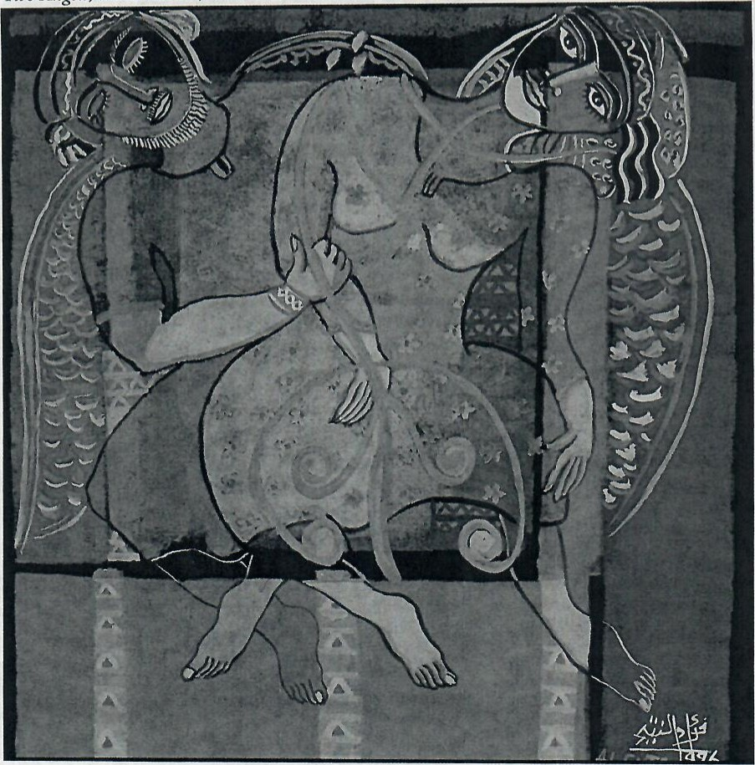
Traditional strictures put all their resources on publicly controlling the sexuality in women. The consequence is an inner-directed eroticism, where the erotic freedom ofwomen and the suppressed urge of the men erupts into an explosive fieedom in the bedroom. In Al-Futaih's work, art assumes a truth which teases social taboos and coaxes imprisoned urges.

vatism of Yemeni traditional society treats as taboo, that Yemeni men want women to hold back in public. In AlFutaih's work, traditional strictures have their own hypocrisies; they put all their resources on public containment, on publicly controlling the sexuality in women—the consequence is an inner directed eroticism, where the erotic freedom of women and the suppressed urge Of the men erupts into an explosive freedom in the bedroom. In Al-Futaih's work, art assumes a truth which teases social taboos and coaxes imprisoned urges. | often approaching midnight, he can be found in the old walled city of Sana'a, walking through a narrow alleyway tiled with black stones, just off the Baab al Yemen—the Gate of Yemen—to his own shop. Crowds of merchants in the Suq haggle with customers over intricately filigreed Bedouin silver, gypsum model Yemeni houses, Hadrami cloth, handwoven baskets and other crafts. Just beyond and to the left, stands the Samsarat al Mansurah, his 30-room, three-story art center where he and other artists sell their work. Al-Futaih is the director of this art center, a quaint but magnificent art dealership, thrust
ach morning he spends five hours with its rich, colorful soul in the midst hours working in his studio. The of a country that is in economic terms schedule is broken only by so poor.
the occasional drought of the The nature of Al-Futaih's art is a imagination. Afternoons and evenings, result of growing up in the charged

Untitled portrait, mixed media on paper, 1995
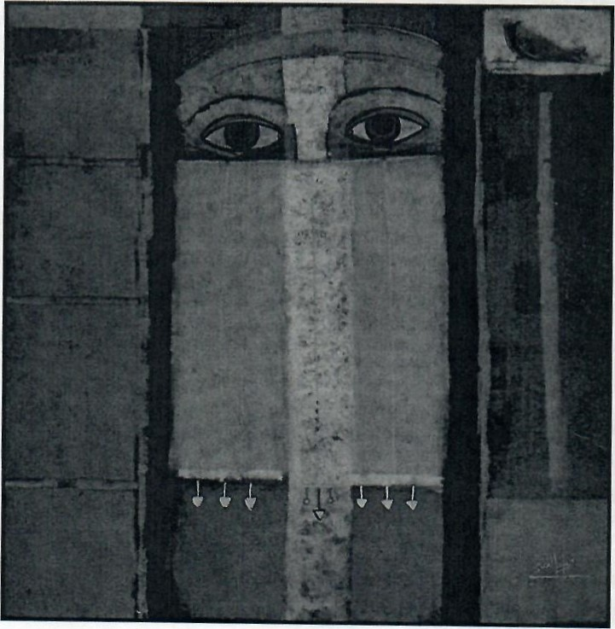
Al-Futaih's art conveys women who appear subdued but dignified; who speak their condition by revealing strong spirits in their eyes and explosive sexuality in their shapes
political environment of colonial and post-colonial Yemen, and of studying art and theater in Cairo, Dusseldorf, Cologne, and other European cities. He continues his work from his studio in Sana'a and his shop in the old city.
His paintings and etchings have received public recognition. In 1989, he was awarded Yemen's National Award in Arts and Culture. He received a medal from the Museum of Art in Alexandria, Egypt, won a U.N. poster competition, and mounted
exhibitions in eastern and western European capitals, and cities throughout the Middle East, in North Korea, Japan, Indonesia, and the United States.
He was born in 1948 in the Taiz governate of North Yemen, the son of the general director of customs, in the conservative and remote country ruled by the Zayyedi Imams, men who claim descent from Prophet Muhammed. When he was four years old, his father moved the family to the British colonial city of Aden, a major seaport along the shipping lanes between India, Asia, and the Horn of Africa. Schooled in a community of privilege, Fuad AlFutaih copied the art works he found in the texts of art books he found in local bookshops and a mobile library.
As a youth, he lived through revolution: the 1962 overthrow of the Zayyedi Imams in Taiz, and South Yemen's 1967 independence movement. When he was 14 years old, he attended Cairo's prestigious Sayyedia secondary school, and was surrounded by the rhetoric of Gamal Abdel Nasser's Pan-Arabic and Pan-African revolutionary sentiments. Throughout the political foment, however, the young Al-Futaih paid attention only to art, theater, and literature.
He was thrilled by the opportunities in Cairo to study English literature, and the staged works of William Shakespeare. At the Riche Cafe in central Cairo, he met and listened to lectures by journalists and writers such as the Egyptian Nobel laureate, Naguib Mahfouz. And when he returned home for the summers, he paid close attention to the poetry of Muhammed Saad Abdallah and the

A rare departure from the theme ofwomen, Al-Futaih's landscapes reveal breathtaking extremes: elaborate, closely stacked, red mudbrick and firebrick houses on top of mountains tentatively settle on rugged, rolling, reddish-brown mountains that dwarf the wadis, valleys that collect water for irrigation of qat farms far below.
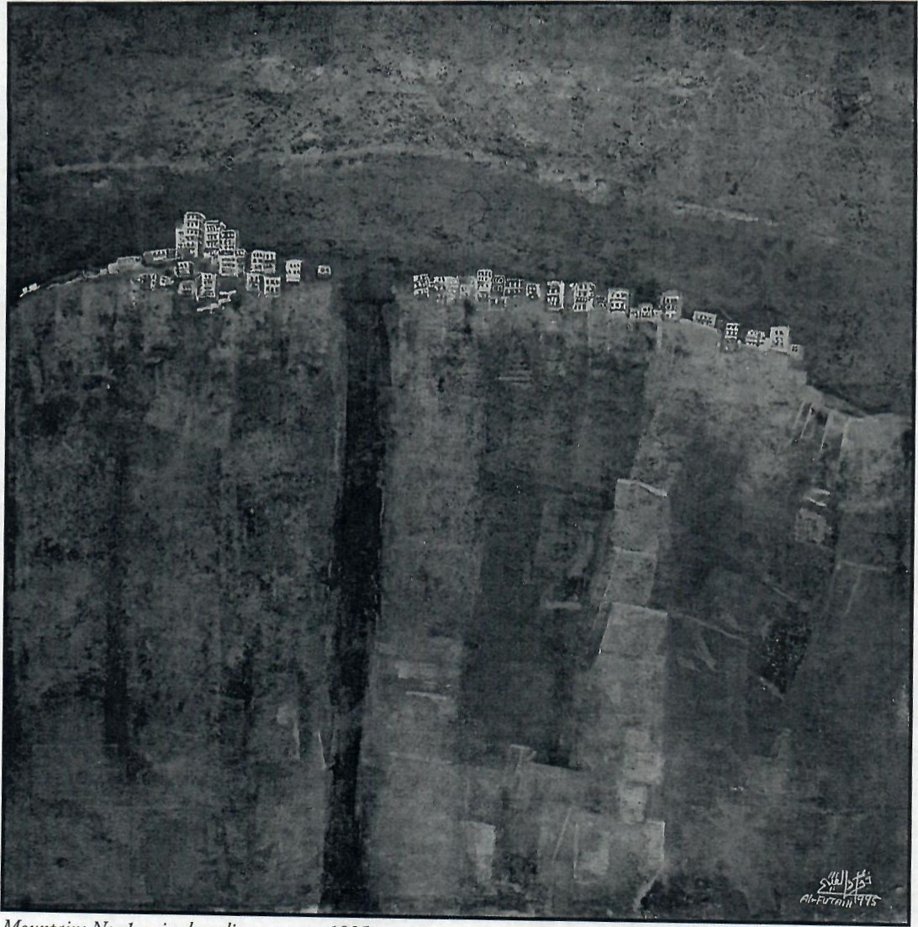

Mountains No. I, mixed media on paper, 1995

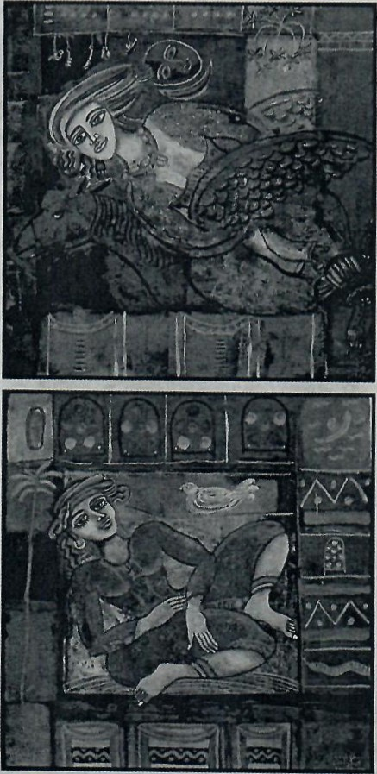
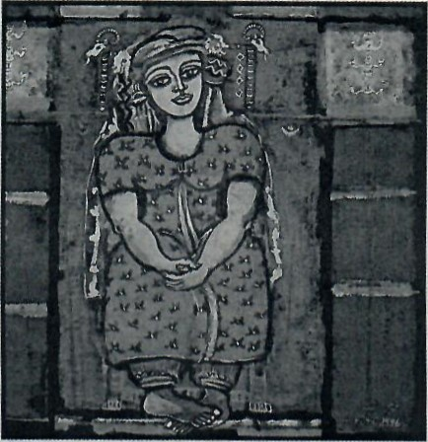
In developing themes the artist depicts the historical with Sheba, upper, in 12 paintings of the Solomonic legend, the traditional figure in a window, middle, in "Woman with a Pigeon" in escape from contemporary traditions, lower, in ''Flying Horse."
music of Ahmed Qasem and Muhammed Murshid Naji, whose voices were pure and gripping as the rainwaters of Wadi Hadramaut.

Politics continued to intrude on the painter's path. During his second year of study at Cairo University, the buildup to the Arab-Israeli war of 1967 forced his return home to Aden. Back home, he was thwarted when the Seventy Days' War began between the Republican Army and the Royalists, who wanted to restore the Zayyedi imams. One day he heard on the radio that he had won an academic scholarship to East Germany. Bombs and rockets were bursting around the city, but he eventually snuck out of town in a taxi. When he reached Aden, however, he was told that the scholarship had been given to another student, Despondent, Al-Futaih returned home to work in his father's pharmacy.
South Yemen awarded him another scholarship to study politics and economics at the University of Baghdad. He took it, but did not like the classes. After two years trying to persuade his government that he wanted to study art, he gave up and went to Dusseldorf, where he befriended members of the faculty of the Academy of Fine Art, where he was admitted to study theater, graphic arts, and painting. While doing doctoral studies at the University of Cologne, he became a commercially successful artist, married, and moved to Berlin where he held several successful exhibitions, including one at the National Museum. With the support of the Iraqi Cultural Center in London, markets opened in London, too. His paintings were part of the First Graphic Arab Artist Exhibition in 1979. After a short period of time in 1980 when he established the department of fine arts in Yemen's Ministry of Culture, he returned to his own art.

Tijan Sallah is the author of Wolof, an ethnography published by Rosen Publishing Company of New York, and edited the 1995 anthology, New Poets of West Africa. He has written three books of poetry and a collection of short stories, Before the New Earth, which was published in 1989.
Sallah is a senior economist at the World Bank.

